Module 1 — Input/output, variables and basic arithmetic
Question 1{Hacker earth:- Read from STDIN, Write to STDOUT}
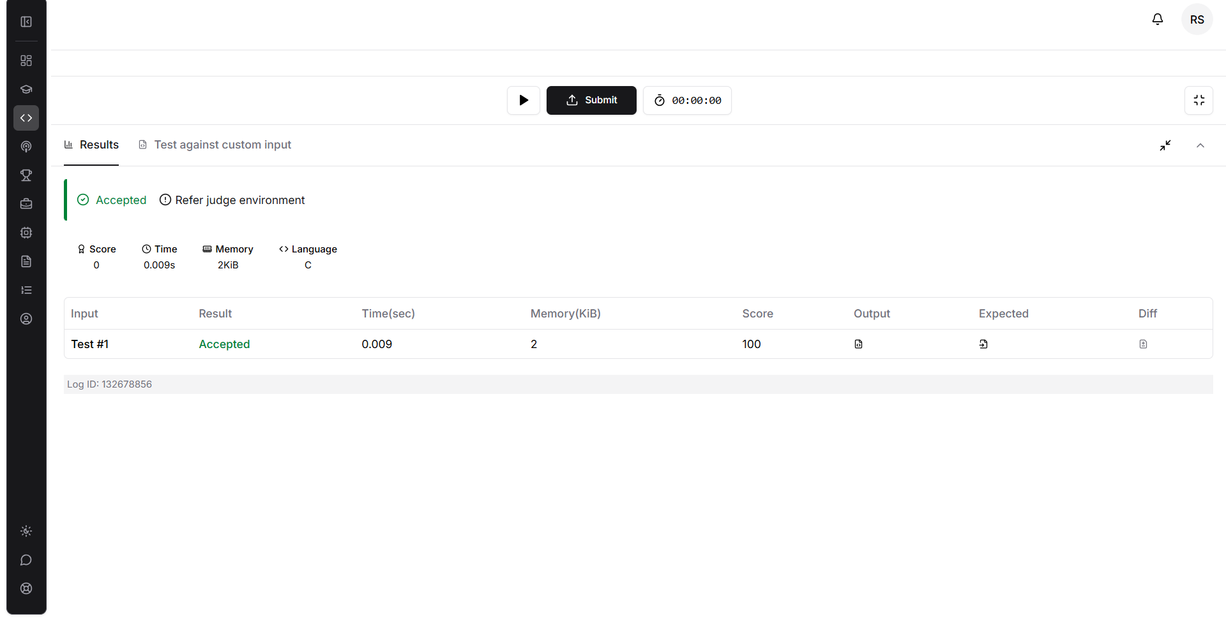
Question2{Hacker rank:-Solve me first}

Question3{Leet code:- 2235. Add Two Integers}

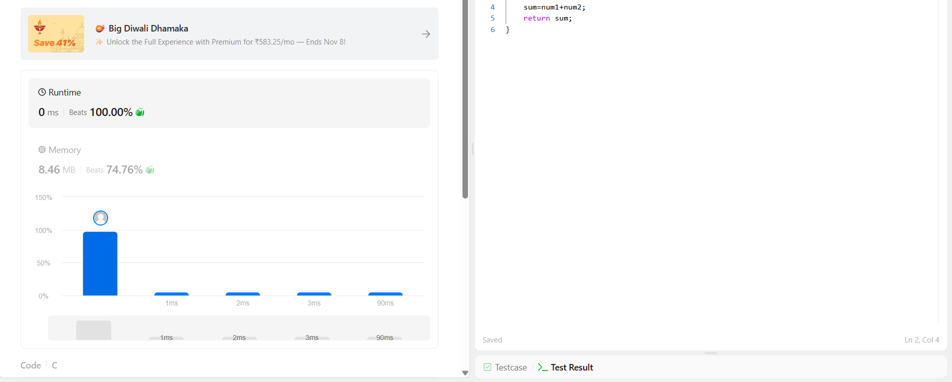
Question 4{Leet code:- 2651. Calculate Delayed Arrival Time}
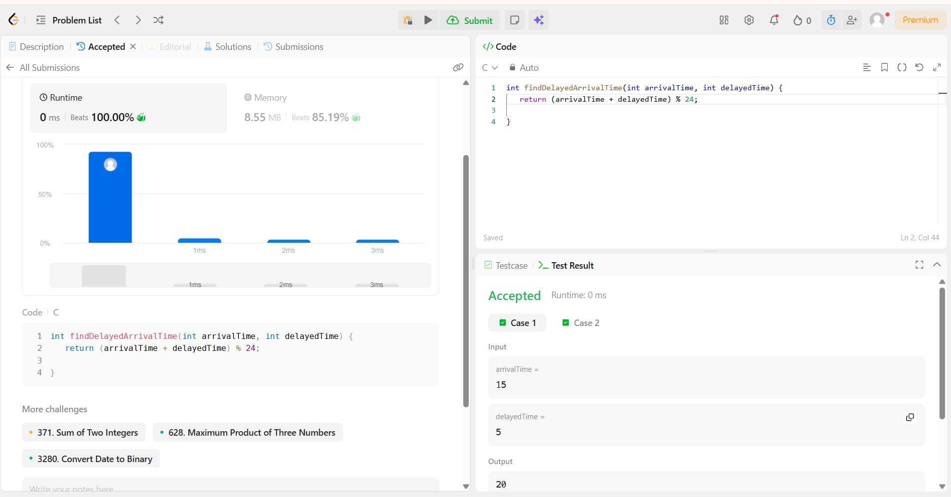
Question5 {Leet code:- 2739. Total Distance Traveled}

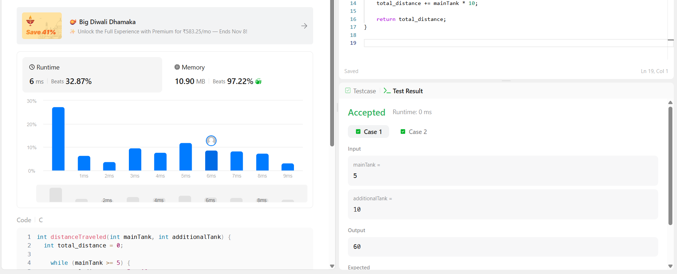
Question6:-{Hacker rank-conditional in c}

Question7:-{Leet code-2413. Smallest Even Multiple}

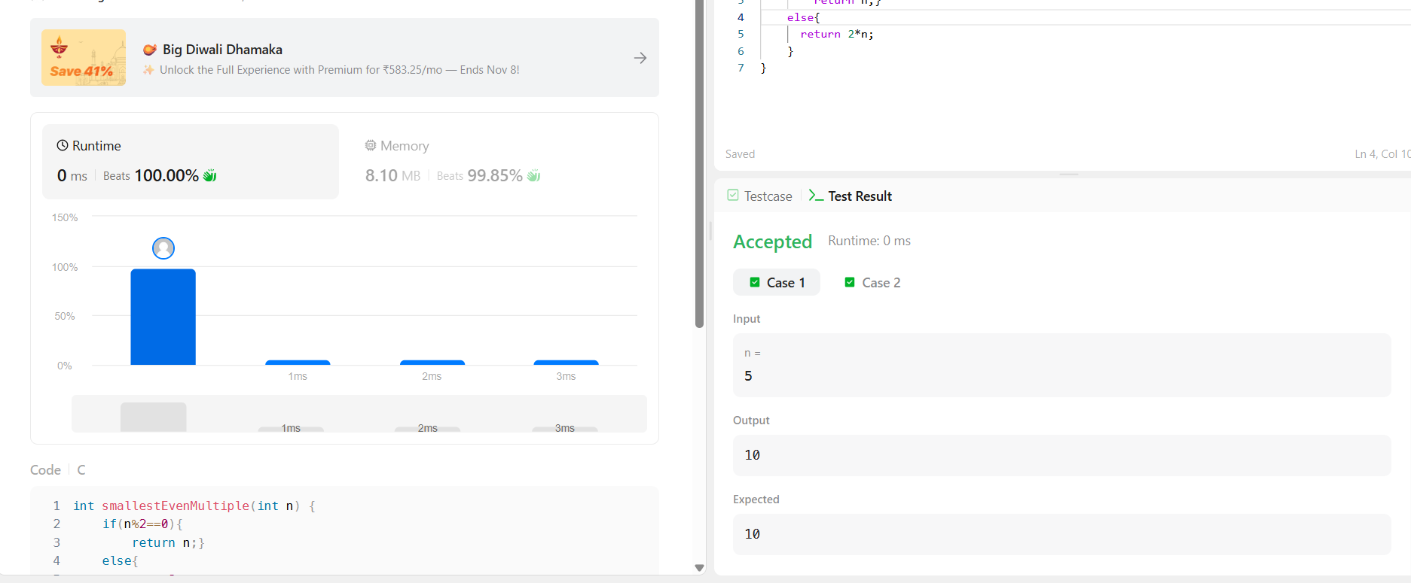
Question8:-{Hacker rank -Grading students}

Question 9:-{ Hacker earth:-Roy and Profile Picture}

Question 10:-{Hacker rank:- FizzBuzz}
Question 11:-{Hacker rank -For Loop in C}
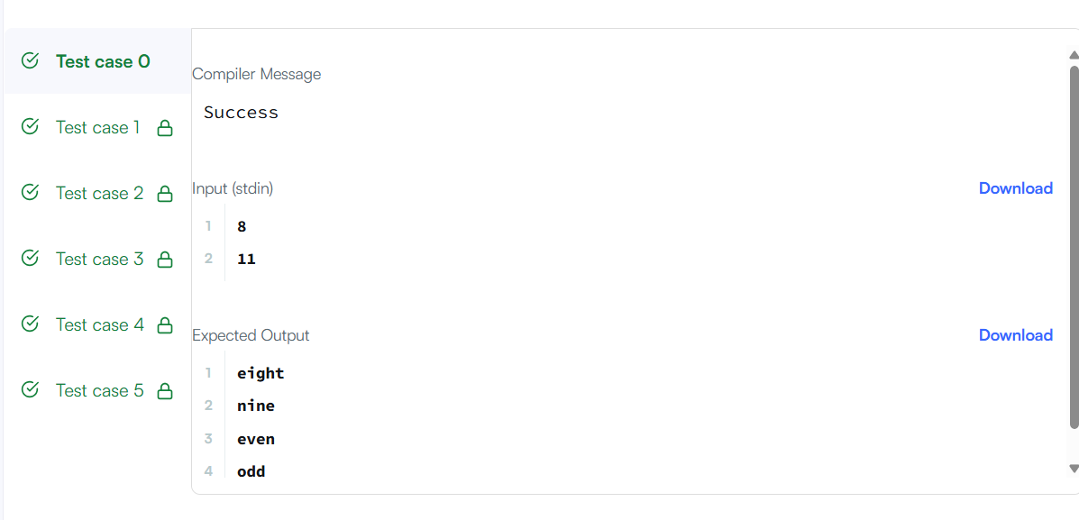
Question 12{leet code-1342. Number of Steps to Reduce a Number to Zero}

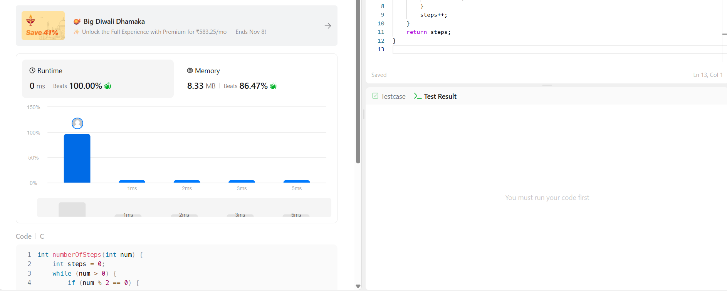
Question 13{leet code-2169. Count Operations to Obtain Zero}
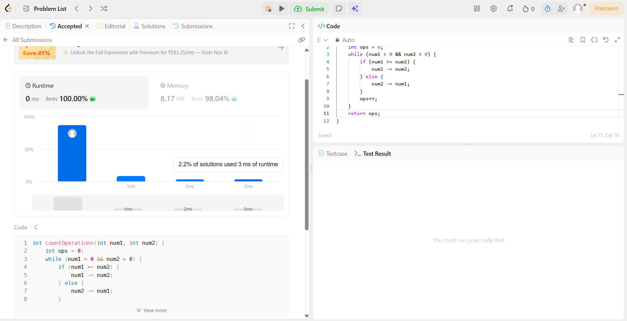
Questiuon 14{ leet code-1523. Count Odd Numbers in an Interval Range}

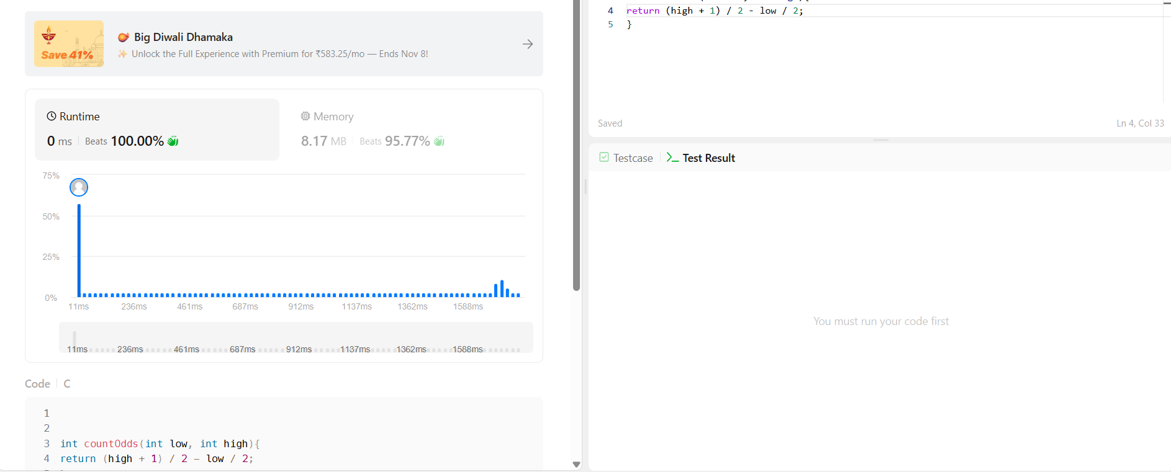
Question 15{leet code-2652. Sum Multiples}

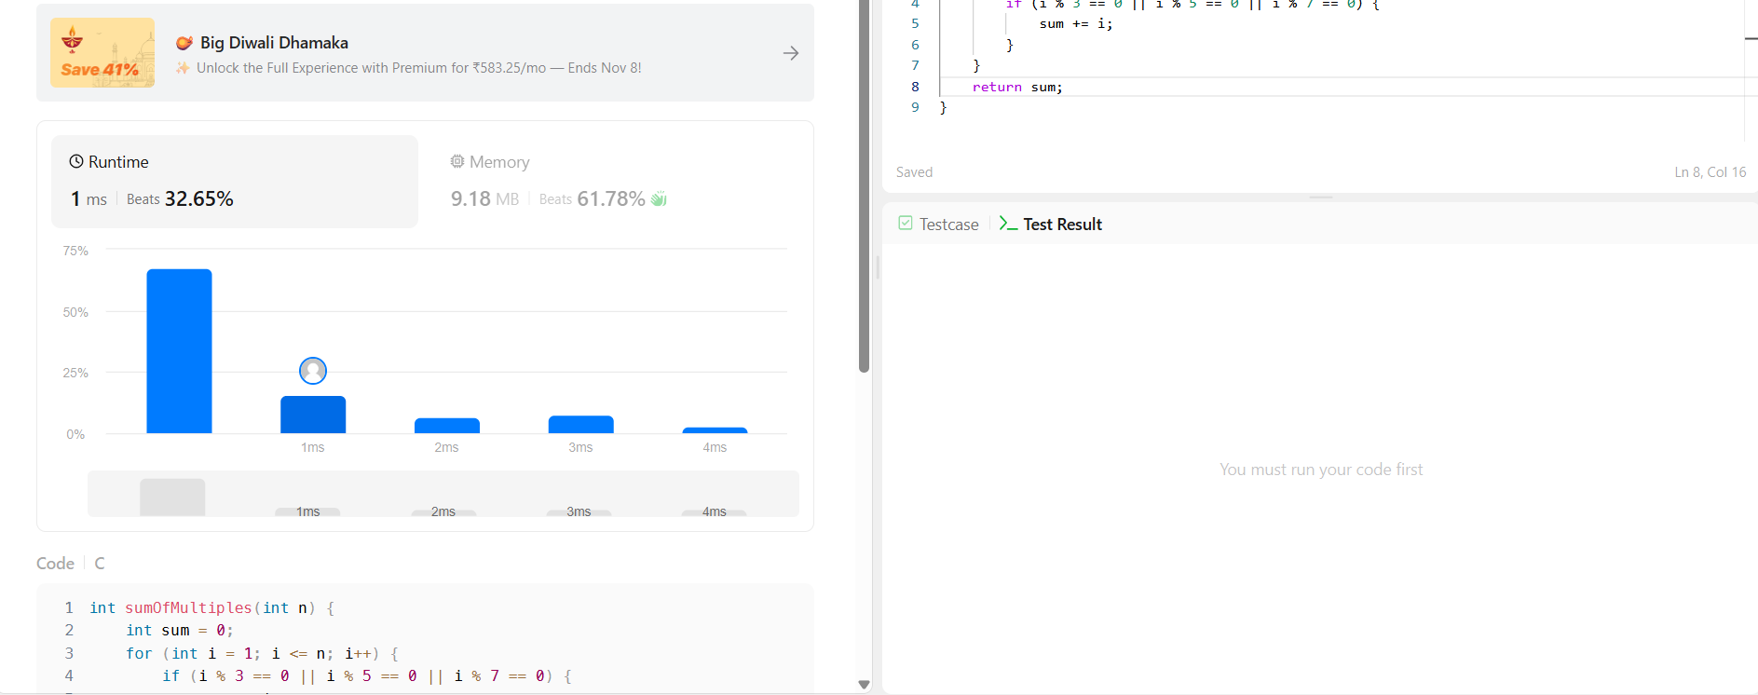
Question 16{Hacker earth-A.Digit Sum}
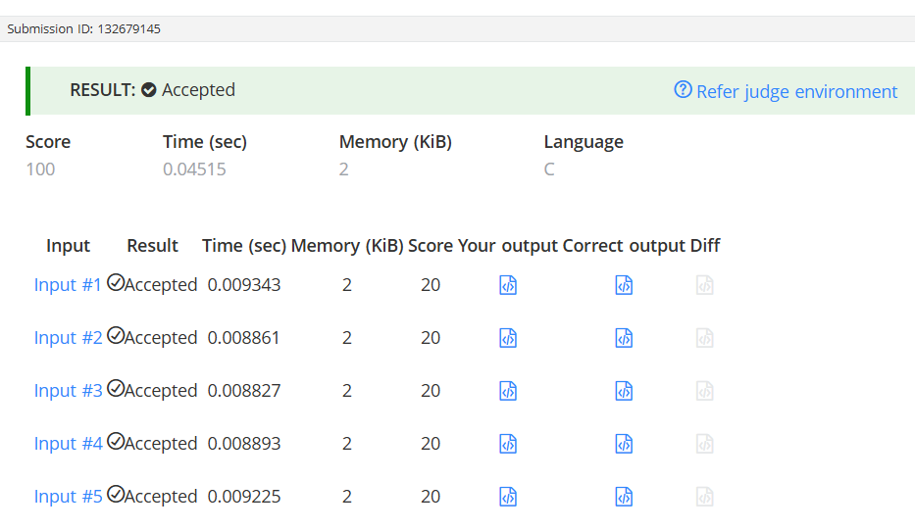
Question 17{leetcode-1281. Subtract the Product and Sum of Digits of an Integer}

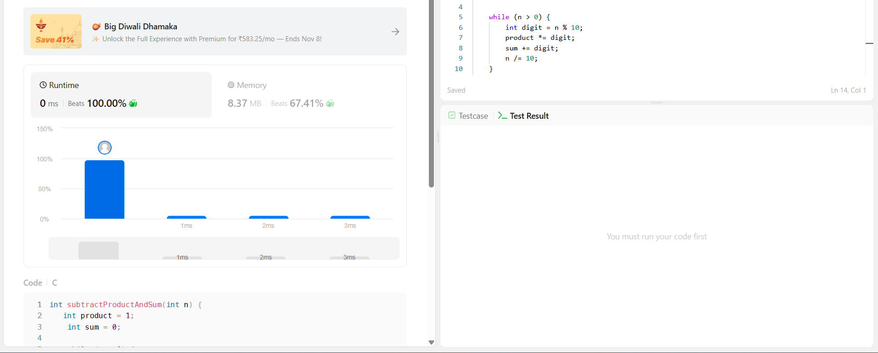
Question 18{leet code-2520. Count the Digits That Divide a Number}

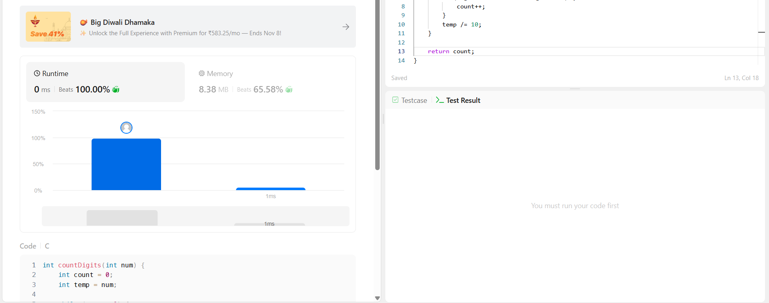Question19{leet code-9. Palindrome Number}

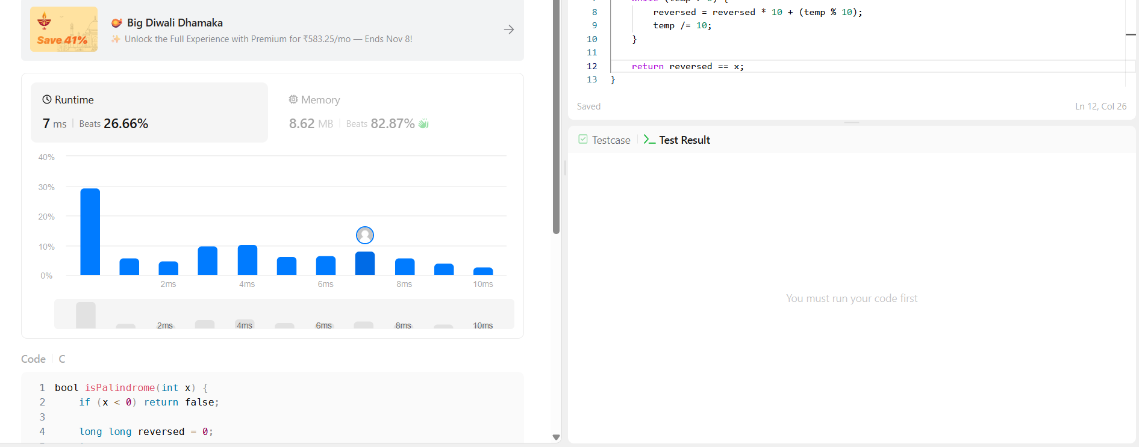
Question20{leet code-7. Reverse Integer}


Question 21{leet code-231. Power of Two}

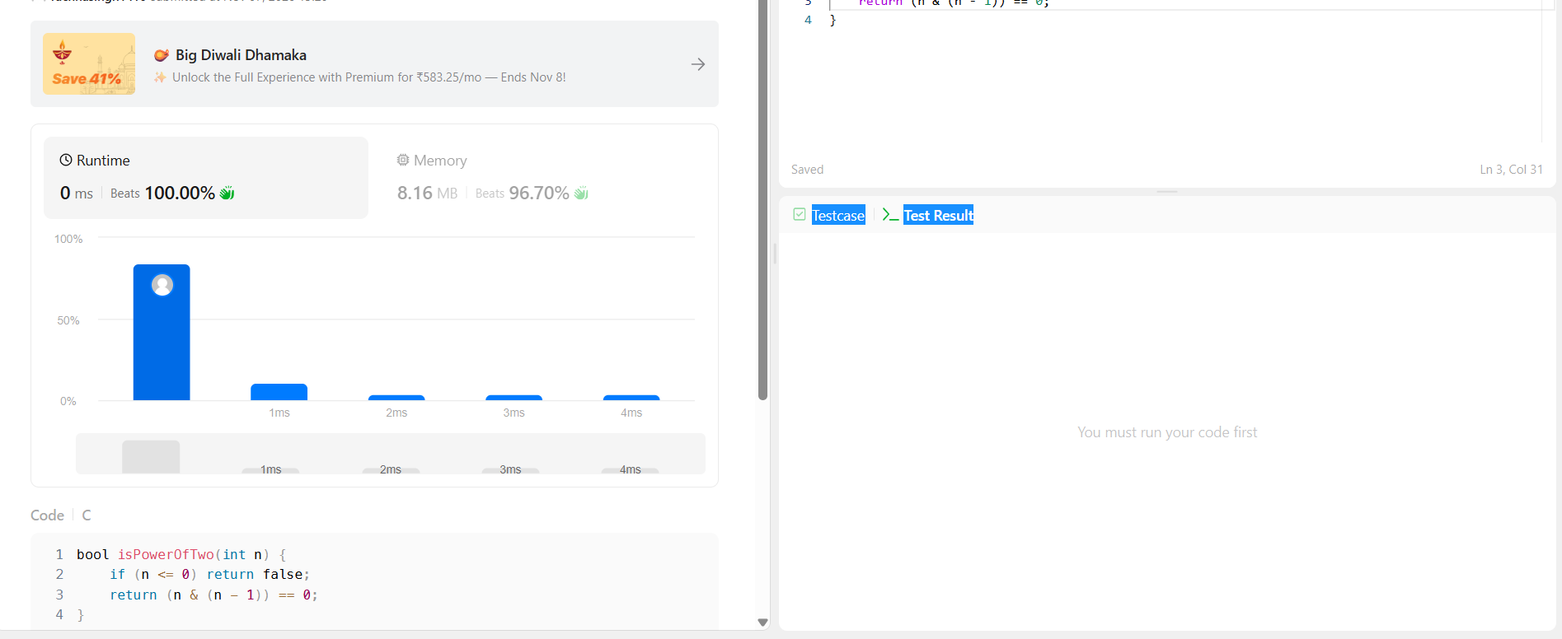
Question 22{leet code-326. Power of Three}

Question23{Hacker earth-Factorial!}
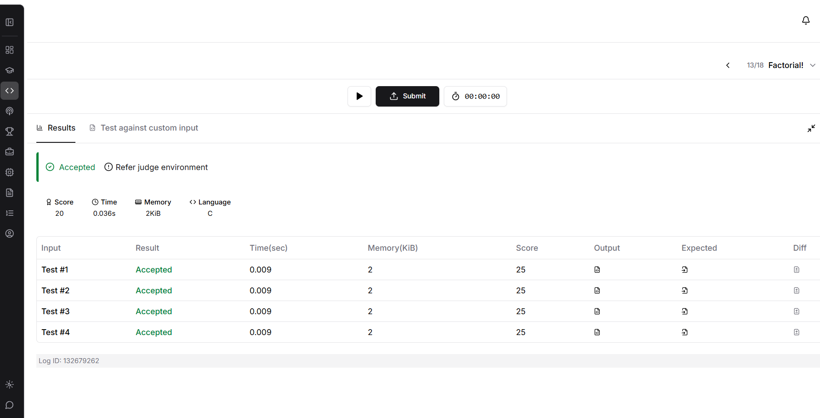
Question24{Hacker earth- count divisor}
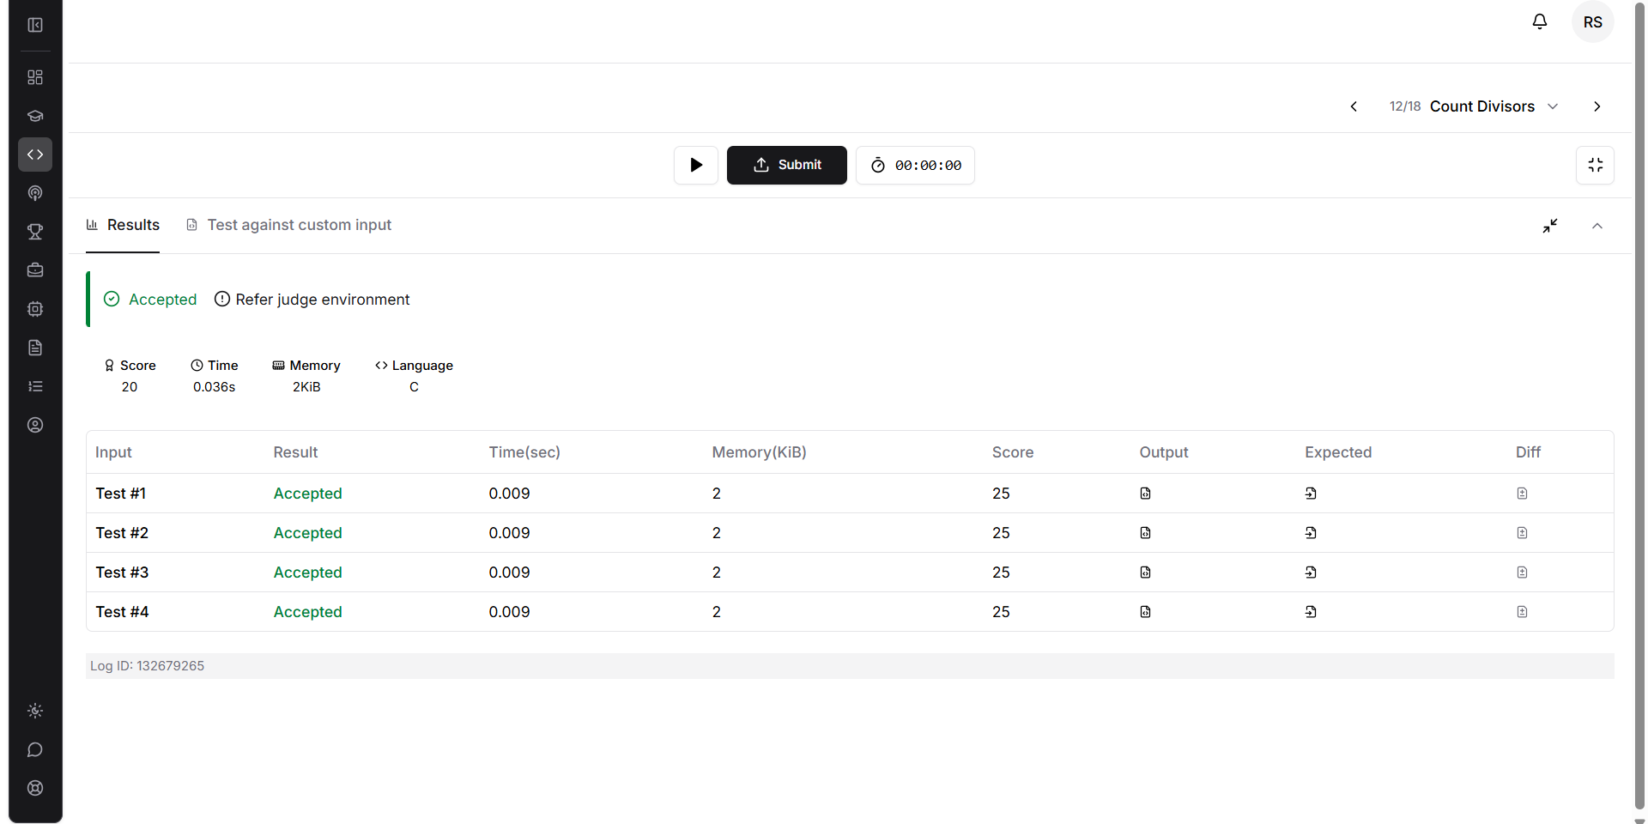
Question25{Leet code-507. Perfect Number}

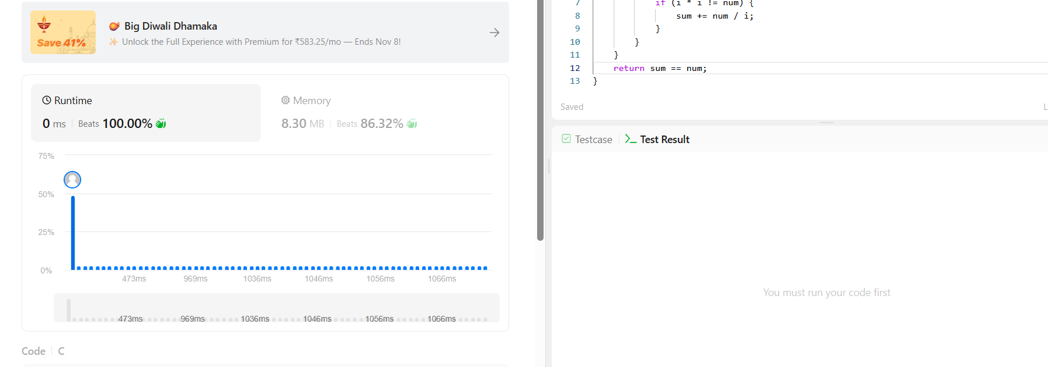
Question26{Hacker earth-Prime Numbers}
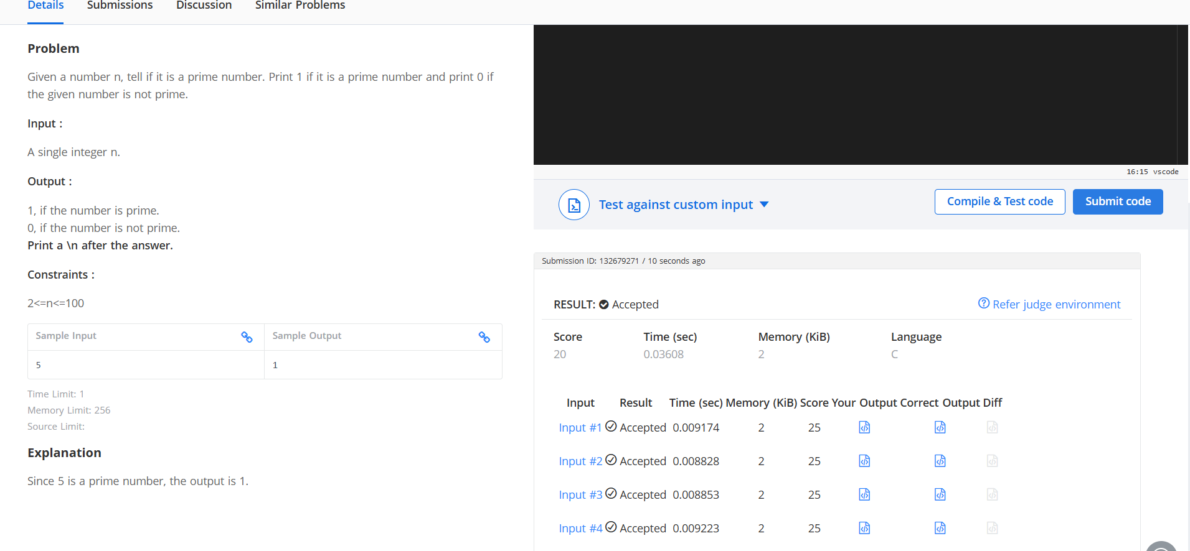
Question27{Hacker rank-Staircase}

Question 28{Hacker rank-Printing Pattern Using Loops}


